**TUGAS 6**

**Kelompok : Herry Effendy**

**Ridwan Abdul Hakim**

* STATE DIAGRAM

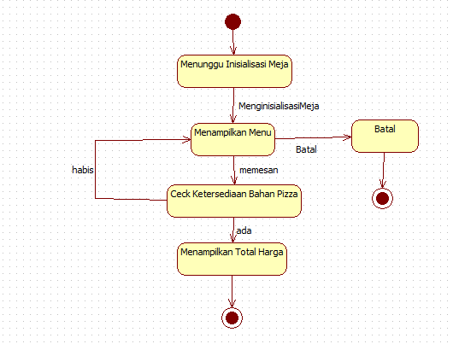

* ACTIVITY DIAGRAM

